**TASK 2 SQL PROBLEM STATEMENT**

1. ***Create a table named “MATCHES” with appropriate data types for columns.***

CREATE TABLE Matches(

Id INT,

Season INT,

City VARCHAR(20),

Date DATE,

Team_1 VARCHAR(30),

Team_2 VARCHAR(30),

Match_Type VARCHAR(10),

Toss_Winner VARCHAR(30),

Toss_Decision VARCHAR(10),

Target INT,

Result VARCHAR(10),

Dl_Applied INT,

Winner INT,

Win_by_Runs INT,

Win_by_Wickets INT,

Player_of_the_match VARCHAR(40),

Venue VARCHAR(40),

Umpire_1 VARCHAR(20),

Umpire_2 VARCHAR(20),

Third_Umpire VARCHAR(30)

)

***To Insert values into the table, use:***

#For example, inserting values for the columns Id, City and venue

INSERT INTO Matches(Id, City, venue)

VALUES(7, ‘Hyderabad’, ‘Rajiv Gandhi International Stadium’)

***To see our created table and its values:***

SELECT * FROM matches;

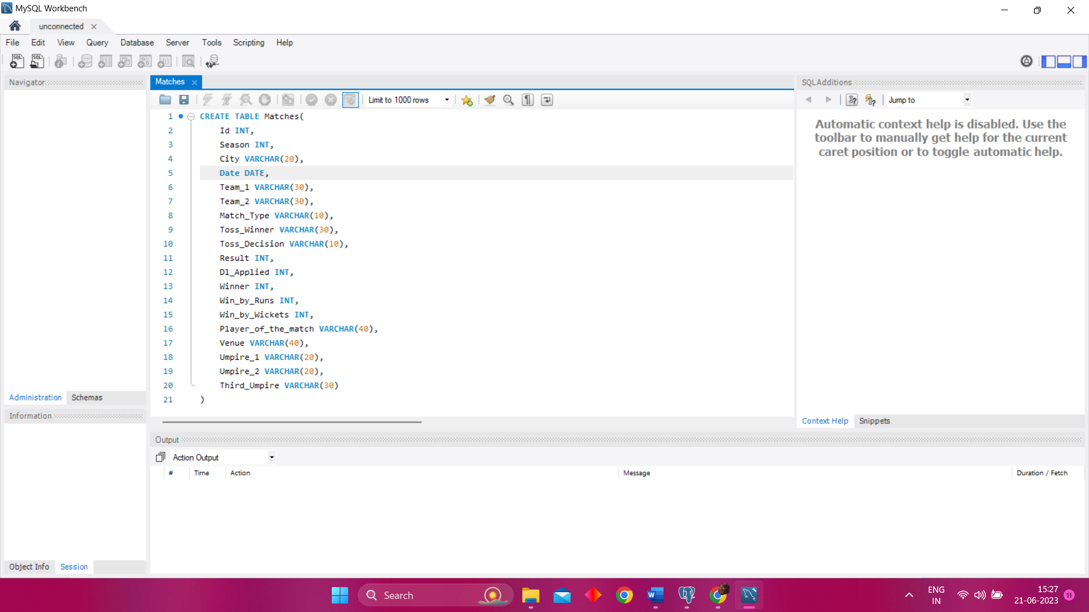

1. ***Create table named ‘Deliveries’ with appropriate data types for columns.***

CREATE TABLE Deliveries(

match_id INT,

Innings INT,

Batting_team VARCHAR(20),

Bowling_team VARCHAR(20),

Over INT,

Ball INT,

Batsman VARCHAR(30),

Non_striker VARCHAR(30),

Bowler VARCHAR(30),

Is_Super_over INT,

Wide_Runs INT,

Bye_Runs INT,

Legbye_Runs INT,

NoBall_Runs INT,

Penalty_Runs INT,

Batsman_Runs INT,

Extra_Runs INT,

Total_Runs INT,

Player_Dismissed VARCHAR(30),

Dismissal_Kind VARCHAR(20),

Fielder VARCHAR(30)

);

***To Insert values into the table, use:***

#For Example,inserting values for the columns Innings, Bowler and Batsman

INSERT INTO matches(Innings, Bowler, Batsman)

VALUES(3, ‘Md Siraj’, ‘MS Dhoni’)

***To see our created table and its values:***

SELECT * FROM Deliveries;

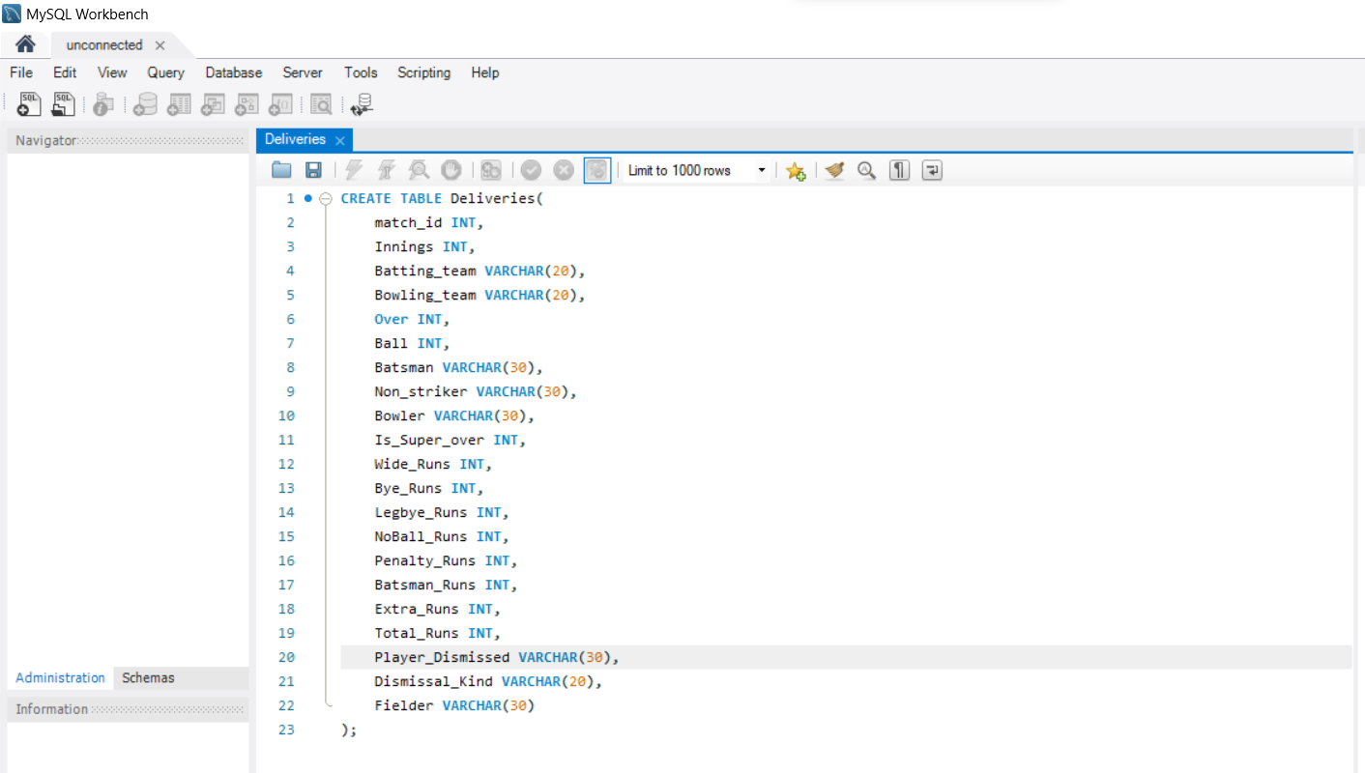

1. ***Import data from CSV file ’IPL_matches.csv’ attached in resources to ‘matches’***

In order to import your CSV file, you can do it directly by selecting your table, and then upon right-clicking it, you will be able to see *IMPORT/EXPORT DATA*

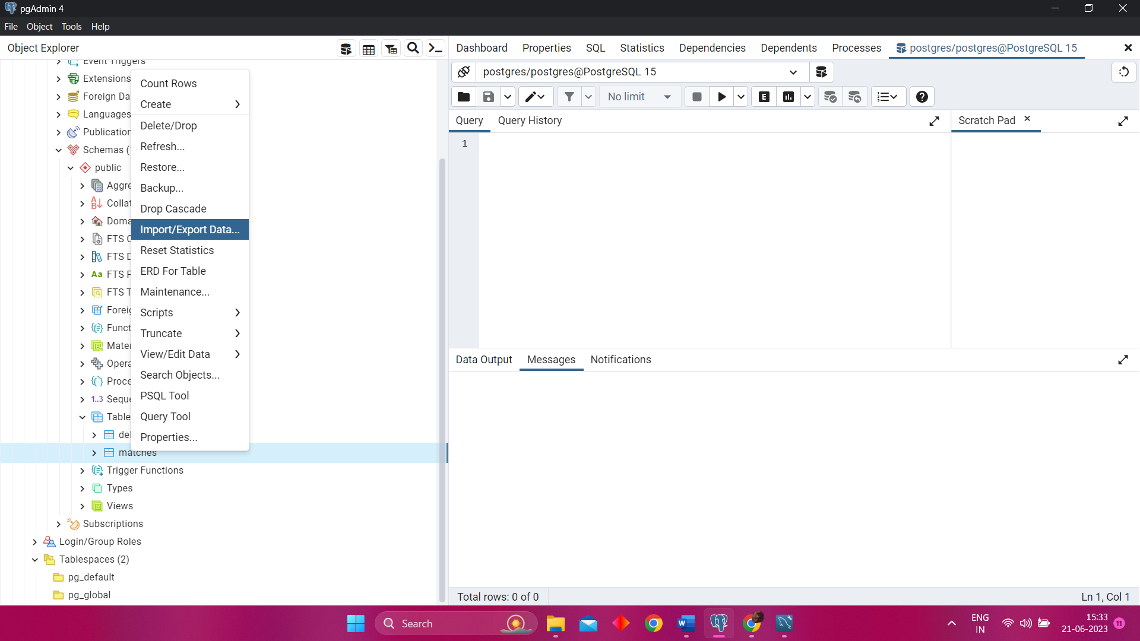

Select *IMPORT/EXPORT DATA*, you will see the following. Now, choose *IMPORT* and enter your required CSV file path link in the Filename box and set the format as *CSV.*

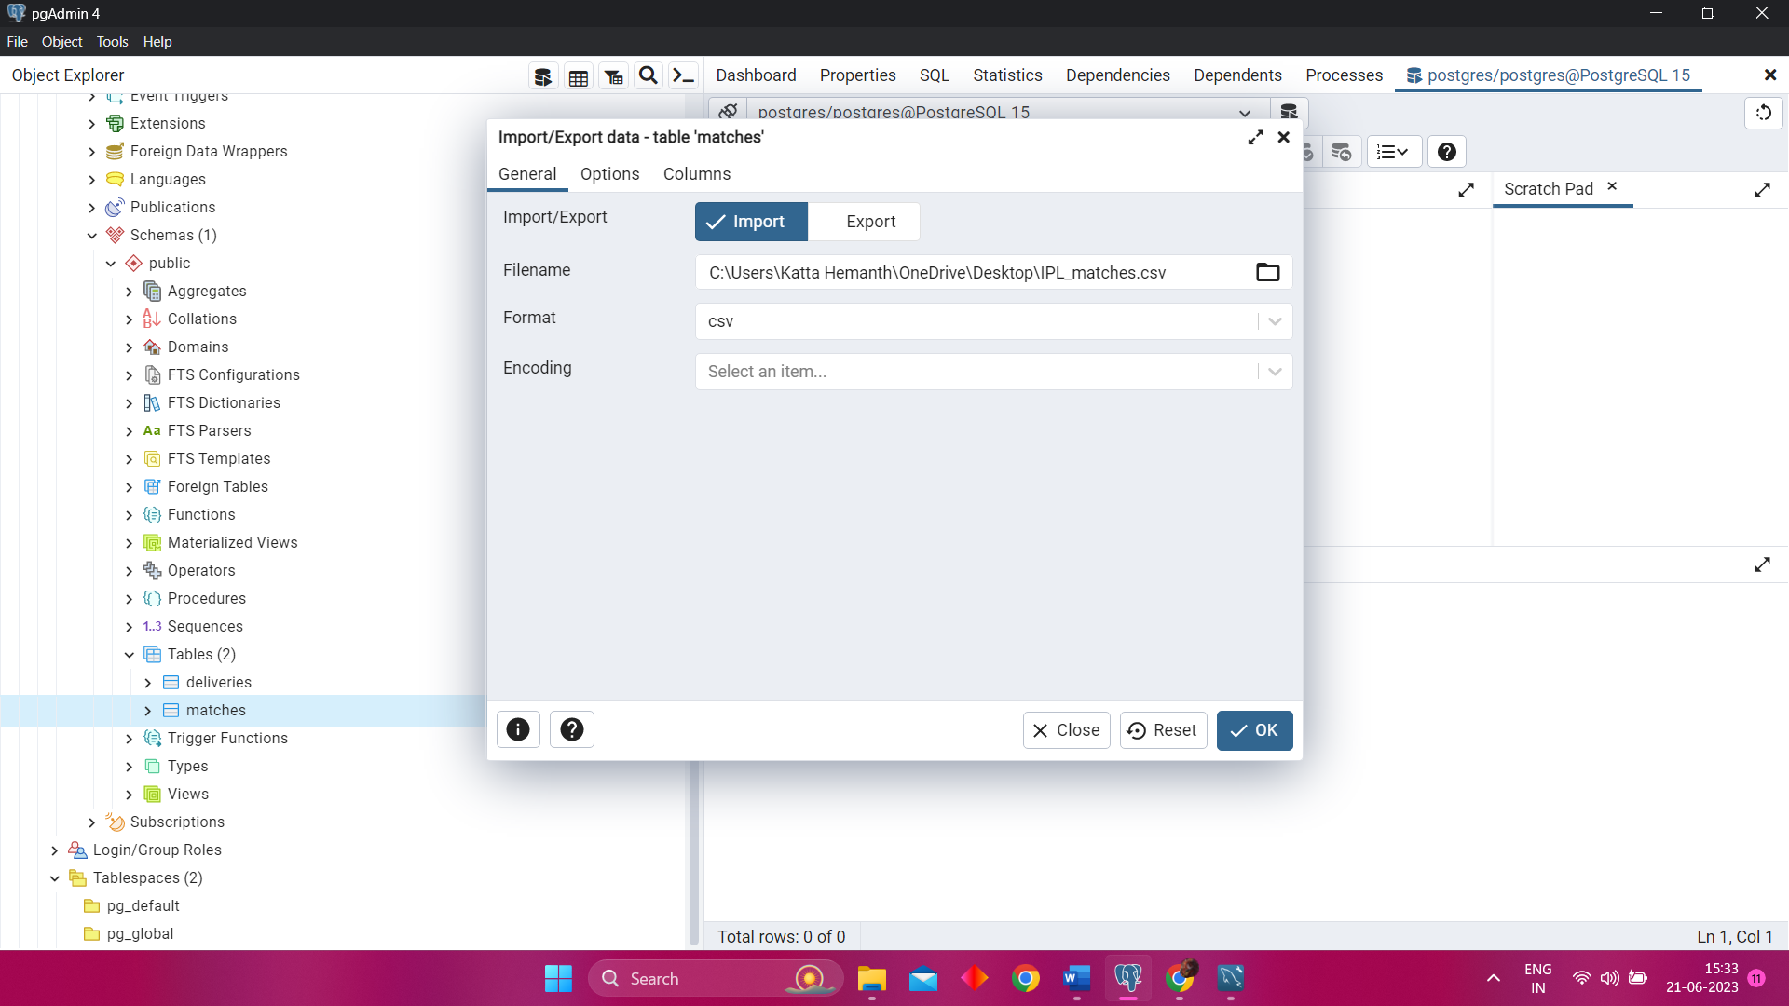

You also have to check the options, where you are advised to ***ON the header*** and ***OFF the OID***, and also set your Delimiter as “ , ” and finally click the ***OK*** button and your csv file is imported

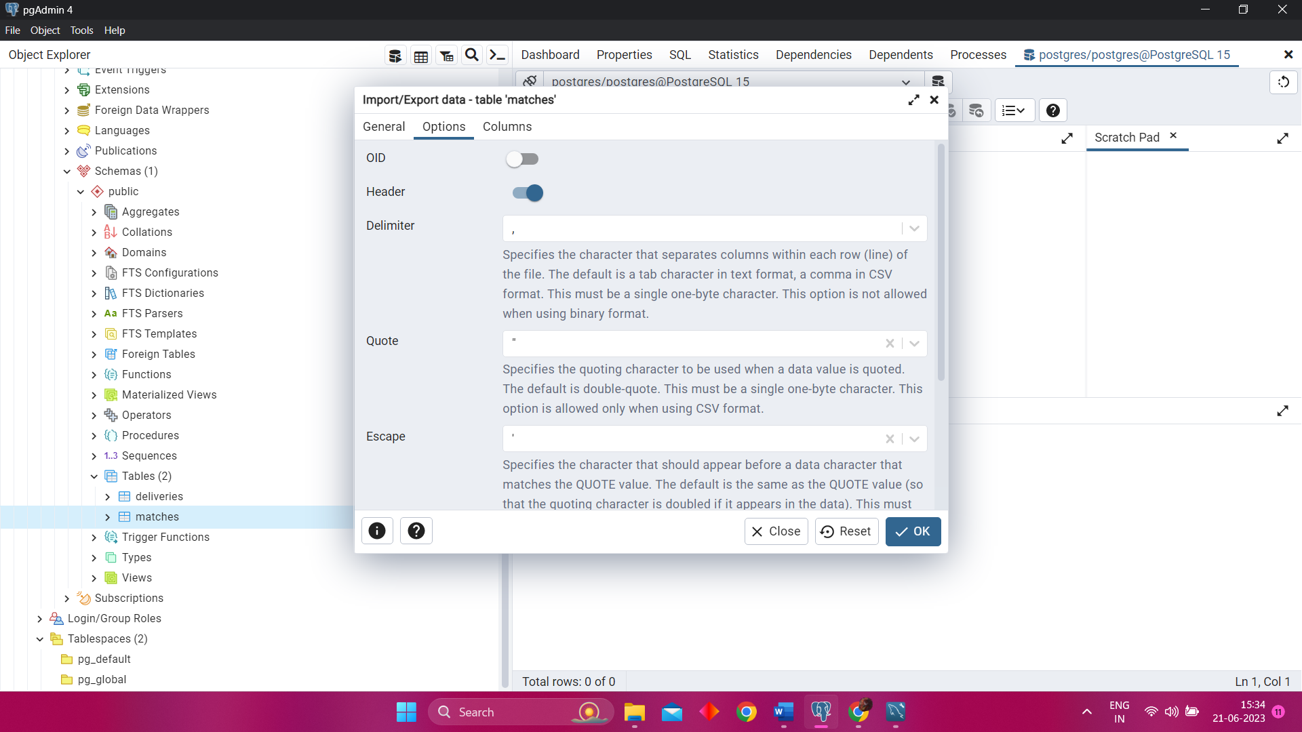

1. ***Import data from CSV file ’IPL_Ball.csv’ attached in resources to ‘deliveries’***

In order to import your CSV file, you can do it directly by selecting your table, and then upon right-clicking it, you will be able to see *IMPORT/EXPORT DATA*

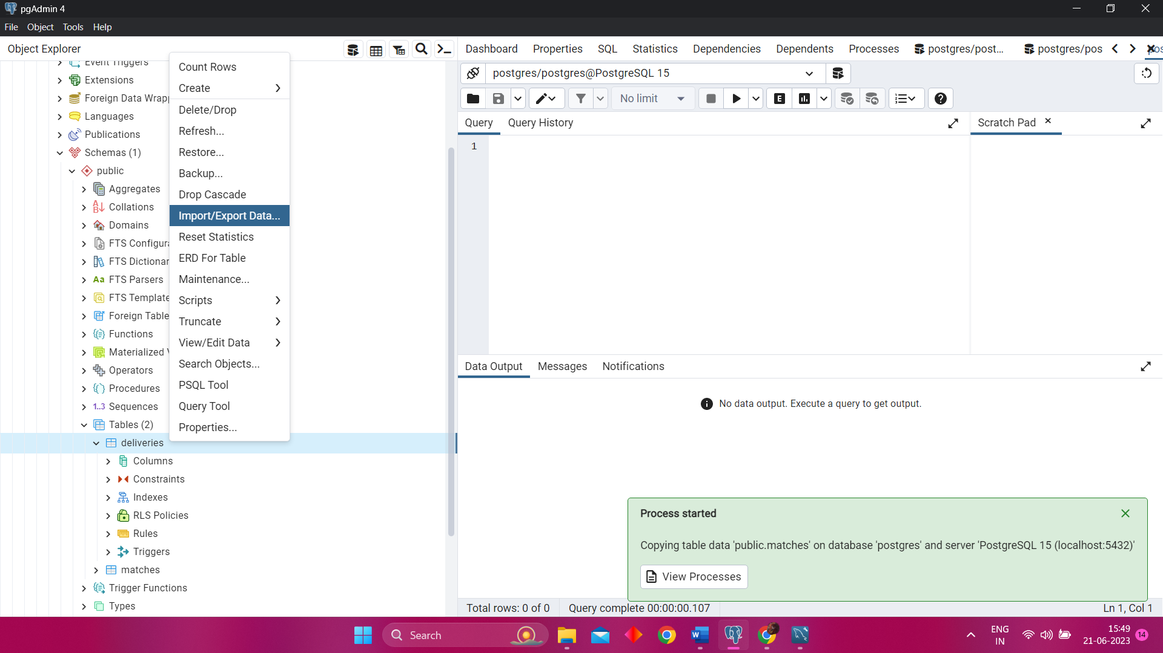

Select *IMPORT/EXPORT DATA*, you will see the following. Now, choose *IMPORT* and enter your required CSV file path link in the Filename box and set the format as *CSV.*

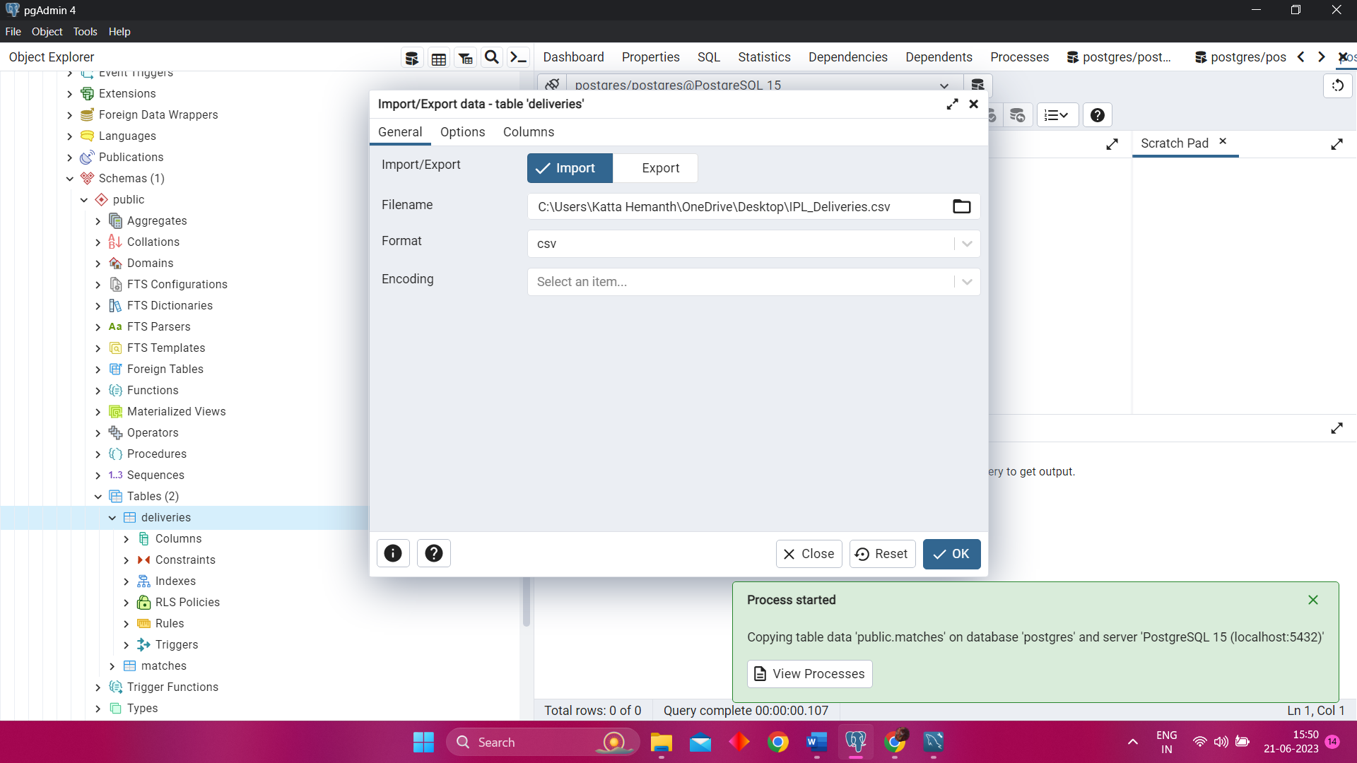

You also have to check the options, where you are advised to ***ON the header*** and ***OFF the OID***, and also set your Delimiter as “ , ” and finally click the ***OK*** button and your csv file is imported

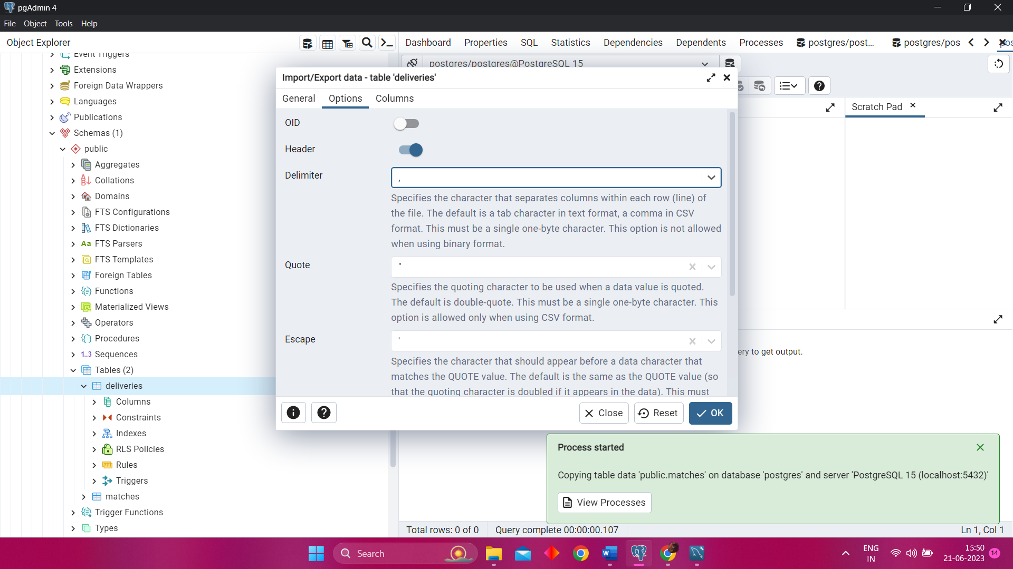

1. ***Select the Top 20 Rows from the Deliveries table***

SELECT * FROM Deliveries LIMIT 20;

1. ***Select the Top 20 Rows from the Matches table***

SELECT * FROM Matches LIMIT 20;

1. ***Fetch data of all the matches played on 2nd May 2013.***

SELECT * FROM Matches WHERE date='02-05-2013';

1. ***Fetch data of all the matches where the margin of victory is more than 100 runs.***

SELECT * FROM Matches WHERE Win_by_Runs > 100;

1. ***Fetch data of all the matches where the final scores of both teams tied and order it in descending order of the date.***

SELECT * FROM Matches WHERE Result='tie' order by date DESC;

1. ***Get the count of cities that have hosted an IPL match.***

SELECT COUNT(distinct city) FROM Matches;